Blåfjell
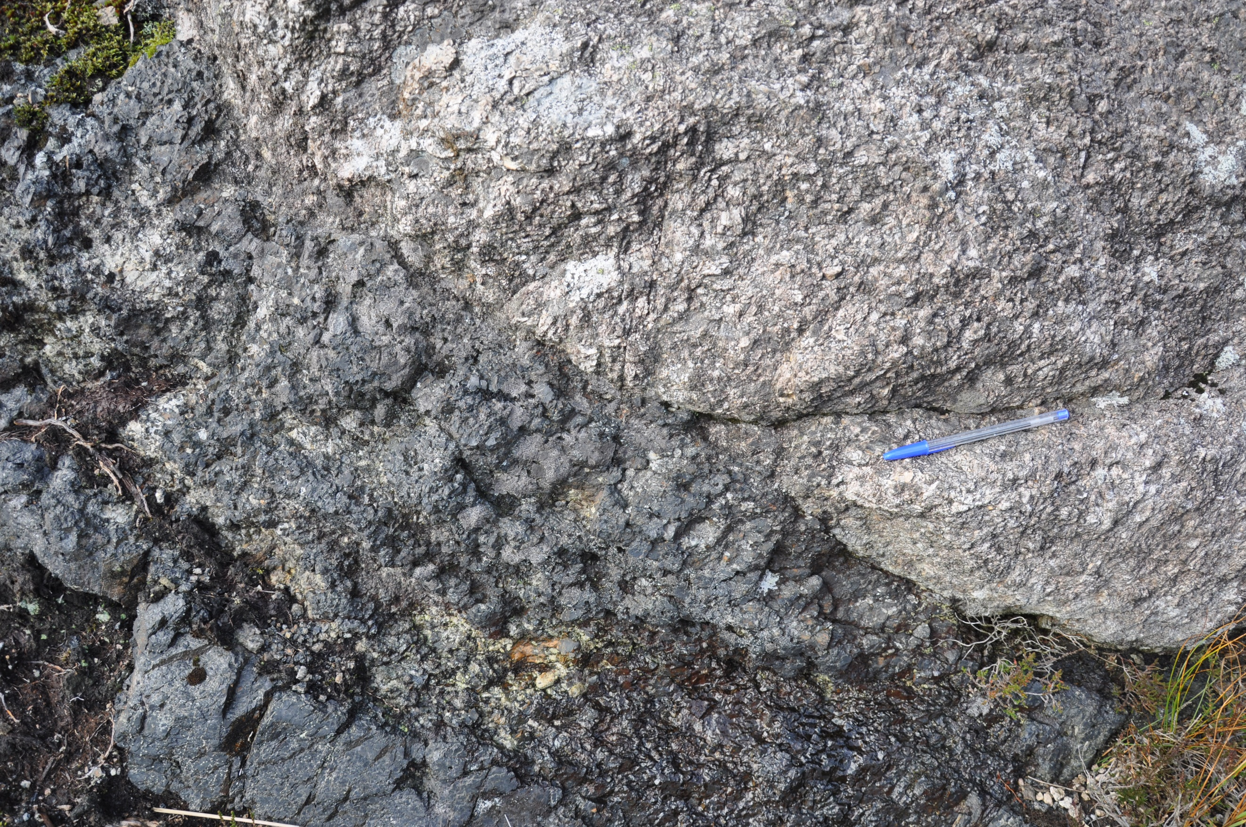
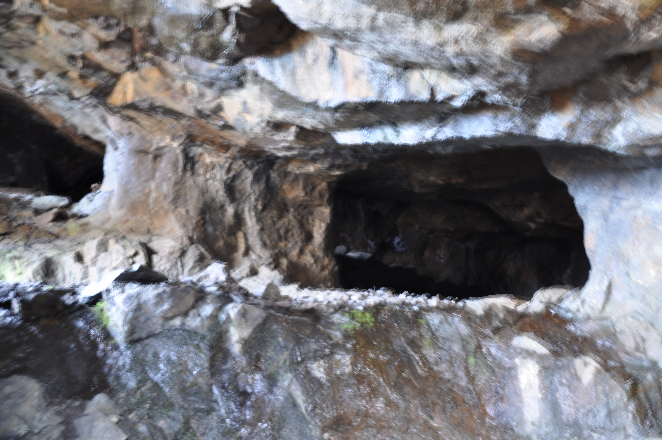
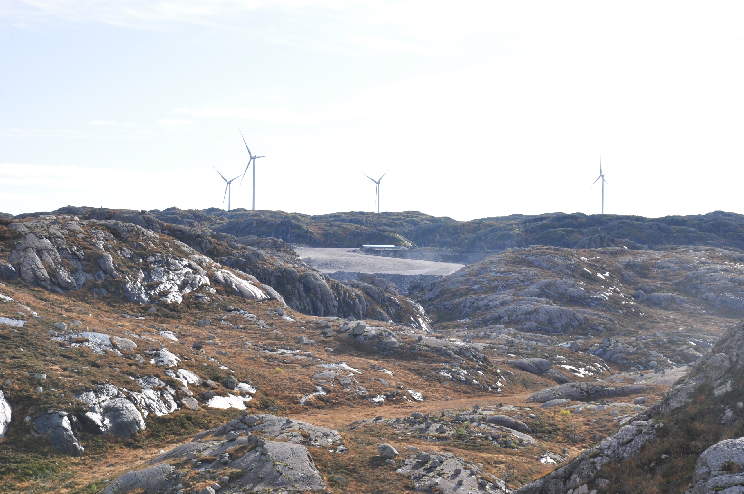
Student Sheet

General instructions to students:
1. Note the main RISKS at the site when you arrive.
2. Respect the geological code of conduct at all times, do not disturb wildlife, close gates, do not remove rocks/fossils or sand from the site.
3. Before leaving transport, check that you have suitable clothing and footwear and the equipment to record your field observations:
4 Pencils
4 Clipboard
4 Task sheet (can vary)
4. Stay close to your teacher/supervisor at all times. (Include site specific hazards if required, water / cliffs etc)
5. Try and complete your observations in as much detail as possible. Listen to the teacher as they explain what you are looking at and ask questions if you are unsure about any aspects of the site.

Tasks to be completed:

Task Description Completed (tick)
1 | Imagine the Rocking rock to be a square. How large is the volume of the rock? Do the calculations in cm. The Rocking rock consists of the rock type Anorthosite. Anorthosite has an approximate density of 2.7 g/cm³. What would then be the approximate weight of the rock?
4a | Describe the rock and the sediments within a small area. Answer the following questions:  What does the sediments consist of?  What is the weight?  How does the sediments look compared to the surrounding rocks?  Are some of the minerals familiar to you?  Try and come up with a theory to why this part of the mountain dissolves into gravel while the surrounding mountain does not.
4b | Can you follow the dyke?  Count the meters of how far it can be followed and use the compass to describe the direction.
5 | Study the ilmenite.  How does the ilmenite look compared to the anorthosite and norite? Describe and draw with color, appearance, texture, grain size and weight in mind.
6 | Top mine  Make a profile from the outside of the top mine from east to west. Use your compass to find the direction. Note the altitude of the different entrances.  Make an explanation to why you think the mine got the shape is has today. It might help to study the boundary of wall and roof/floor in one of the mine entrances.  In the center of the mine there is a large pillar standing. What does it consist of? And why do you think they saved this pillar?
7 | Find a norite dyke cutting the anorthosite. Make a sketch of it, measure it (height, width, length) and describe the difference in texture between the anorthosite and the norite.  Why is the norite dyke less eroded than the surrounding anorthosite?
8 | Study the outcrop, describe and draw a sketch of it (textures in the rock, rock boundaries).
9 | What kind of resources are visible around you?  How many windmills can you see?  If one windmill produces 7,7 GWh/year (7 700 000 kWh/year), how many households can all the windmills here produce power to if one household use an average of 20 000 kWh/year.  Can you think of any conflicts that might appear because of the resources in the area?
10 | Glacial erratic can be found on many mountains around. How many do you see? Describe how you think they got here.
11 | Study the deposits.  - Describe and draw them with shape and grain size in mind  - Are all the rocks of the same rock type? Or are there many different?  It is greener in the valley than on the mountain tops. Why?

Activities to be provided for each site (examples provided by CCGHT)

* At least one activity must get students to think about Drifting Apart connections, easily linked to from teachers notes.

Name
Location

1. Rocking rock

4a. Weathered rocks

4b. Dyke

5. Study the ilmenite

Name
Location

6. Top mine

Name
Location

7. Norite dyke

Name
Location

8. Outcrop

Name
Location

9. Resources

Name
Location

10. Glacial erratics

11. Moraines

